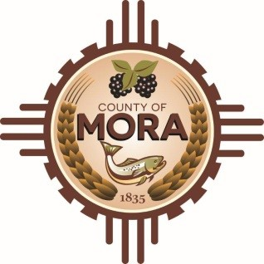

Board of County Commissioners
Special Meeting
David Cargo Public Library
Highway 518, Mora, NM 87732
May 9, 2025
2:30 p.m.

MEETING NOTICE
Join Zoom Meeting
Meeting ID: 999 6369 9950
Passcode: 265361

Zoom Link: https://zoom.us/j/99963699950?pwd=EkmkbADJ4ZbwUfISd7W39im4bbCWnL.1

Find your local number: https://zoom.us/u/acTZyxTIXj

The Mora County Board of Commission will hold a Special Meeting on Friday, May 9, 2025, at 2:30 p.m. at Highway 518, Mora, NM 87732. Agendas may be obtained on Tuesday, May 6, 2025, at 2:30 p.m. at https://towncloud.io/go/mora-county-nm/
If you are an individual with a disability who is in need of a reader, amplifier, qualified sign language interpreter, or any other form of auxiliary aid or service to attend or participate in the hearing or meeting, please contact the County Manager’s Office at the Mora County Courthouse at least one week prior to the meeting or as soon as possible. Public documents, including the agenda and minutes, can be provided in various accessible formats. Please contact the Mora County Managers Office at 575-387-5925 if a summary or other accessible format is needed.
If you have difficulties connecting to Zoom, call the Manager’s Office at 575-387-5925
PUBLISH:
Posted: Bulletin Board, and County Website; 5-6-25

