***Mora County Veterans Memorial Committee***

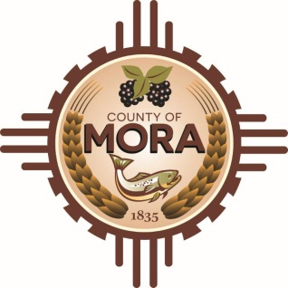

***Joe Gene Pacheco Max Garcia***

**ChairmanTreasurer**

***Harold Nolan Julian Olivas***

**Vice Chair Secretary**

**Veterans Memorial Committee**

**Mora Library**

**NM 518 Mora, NM 87732**

**May 13, 2025**

**1:00 p.m.**

**Agenda**

Zoom Meeting ID: 922 9093 4855

Passcode: 657464

Zoom Link: <https://zoom.us/j/92290934855?pwd=z9U70VyWOfoZCS3ZqT0vzdPf6NVALF.1>

Find your local number: <https://zoom.us/u/aelMMQ5M1>

1. Call to Order
2. Veterans Salute to the Flag of the United States of America
3. Approval of Agenda
4. Approval of Minutes
5. April 8, 2025
6. Discussion:
7. Update from Tom Cordova, Lloyd & Associates
8. Update by Larry Garcia
9. County Commission Meeting April 30, 2025-Approval of Committee Appointments
10. Discussion
11. Memorial Banners-Betty Griego
12. Memorial Pamphlet-Betty Griego
13. Unfinished Business
14. New Business
15. Adjournment

If you are an individual with a disability who is need of a reader, amplifier, qualified sign language interpreter or any other form of auxiliary aid service to attend or participate in the meeting, please contact the Mora County Administration office located on Highway 518, 1 Courthouse Drive, Mora County Courthouse, Mora, New Mexico, as soon as possible at 575-387-5279.

Posted: Bulletin Board, County Website; 5/10//25