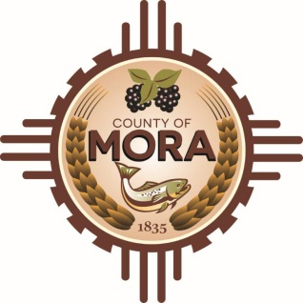***County Commissioners***

***George A. Trujillo Clarence Aragon***

*Commission Chair Deputy County Manager*

***Johnny Trujillo***

*Commission Vice-Chair*

***Veronica M. Serna***

*Member*

**⚠️ Flood Advisory – Mora County ⚠️**

Due to high water volumes and ongoing flooding, **all residents are advised to stay off the roads throughout Mora County** until further notice.

**Do NOT attempt to cross areas with high water or ROAD CLOSED barriers**, as conditions are dangerous and unpredictable.

The following roads are currently **closed**:

* **C001 (La Cebolla)**
* **C001A(Pine Tree Rd)**
* **A011 (South Carmen area)**
* **A010 (El Oro)**
* **A004 (Quitana Rd) “Sleepy Hallow in Ledoux”**
* **A030 (El Alto)**

Please stay tuned to local updates and emergency services for further information.

Stay safe.

John Romero: (Road Superintendent) 575-447-0839

Clarence Aragon (Deputy County Manager) 505-617-4207

Monica Mondragon (Road Administrative Assistant) 505-617-4397

Eugene Pino (Emergency Manager) 505-429-1921

All Immediate Emergencies PLEASE CALL 911