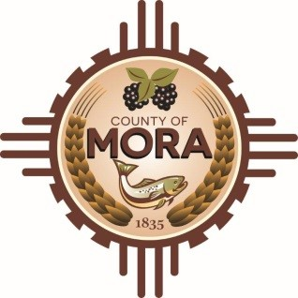

**Board of County Commissioners**

**Work Budget Session**

**David Cargo Library**

**HWY 518 near the entrance to the County Complex (1 Courthouse Drive)**

**Mora, NM, 87732**

**Monday May 19th, 2025**

**1:00 pm**

**MEETING NOTICE**

**Join Zoom Meeting**

Meeting ID: 966 6369 9950

Passcode: 265361

Zoom Link: [**https://zoom.us/j/96635265808?pwd=ajFqNWxRNzFMMjUvVzV6N1FqbmprUT09**](https://zoom.us/j/96635265808?pwd=ajFqNWxRNzFMMjUvVzV6N1FqbmprUT09)

Find your local number: <https://us06web.zoom.us/u/kBS6OqdwW>

The Mora County Board of Commission will hold a **Budget Work Session** on Monday May 19th, 2025, at 1:00 at the Mora County David Cargo Library, HWY 518 near the entrance to the County Complex (1 Courthouse Drive) Mora, New Mexico. Agendas may be obtained at the Mora County Manager’s Office on Friday May 16 th, at 1:00 p.m. or at <https://towncloud.io/go/mora-county-nm/>

*If you are an individual with a disability who is in need of a reader, amplifier, qualified sign language interpreter, or any other form of auxiliary aid or service to attend or participate in the hearing or meeting, please contact the County Manager’s Office at the Mora County Courthouse at least one week prior to the meeting or as soon as possible. Public documents, including the agenda and minutes, can be provided in various accessible formats. Please contact the Mora County Managers Office at 575-387-5925 if a summary or other accessible format is needed.*

If you have difficulties connecting to zoom, call the Manager’s Office at 575-387-5925

PUBLISH:

**Posted: Bulletin Board, and County Website; 5/7/2025**