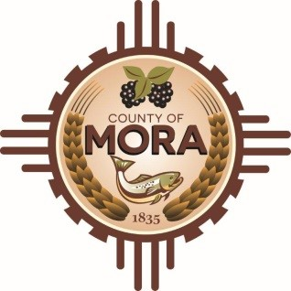

**Board of County Commissioners**

**Special Meeting**

**David Cargo Library**

**NM-518 Mora, NM 87732**

**Monday, April 21, 2025**

**10:00 am**

**MEETING NOTICE**

**Join Zoom Meeting**

Meeting ID: 999 6369 9950

Passcode: 265361

Zoom Link: <https://zoom.us/j/99963699950?pwd=EkmkbADJ4ZbwUfISd7W39im4bbCWnL.1>

The Mora County Board of Commission will hold a **Special Meeting** on Monday, April 21, 2025, at 10:00 a.m. at the David Cargo Library NM Mora, New Mexico. Agendas may be obtained on Friday, April 18, 2025, no later than 10:00 am at <https://towncloud.io/go/mora-county-nm/> and at the County’s Human Resources Office during regular business hours beginning Monday, April 21, 2025.

*If you are an individual with a disability who is in need of a reader, amplifier, qualified sign language interpreter, or any other form of auxiliary aid or service to attend or participate in the hearing or meeting, please contact the County Manager’s Office at the Mora County Courthouse at least one week prior to the meeting or as soon as possible. Public documents, including the agenda and minutes, can be provided in various accessible formats. Please contact the Mora County Manager’s Office at 575-387-5925 if a summary or other accessible format is needed.*

If you have difficulties connecting to Zoom, call the Manager’s Office at 575-387-5925

PUBLISH:

**Posted: Bulletin Board and County Website on April 17, 2025**