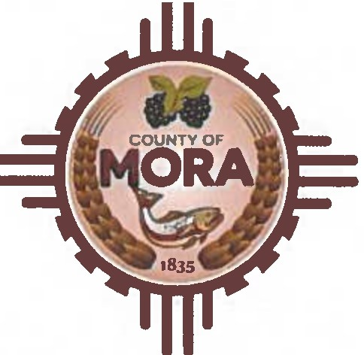

**Job Title:** Bureau of Elections/Deputy Clerk

# Classified/Full-Time - Non-Exempt-$23.00-$26.00 per hour

**Position Summary:**

The Bureau of Elections/Deputy Clerk is a multifaceted role responsible for the comprehensive management of election-related activities. This includes processing voter registrations, maintaining accurate voter files, coordinating polling locations, training election workers, and ensuring the accurate canvassing of election results. Provides essential administrative support to the County Clerk, including records management and meeting transcription. Success in this position requires exceptional organizational and communication skills, a strong work ethic, and the ability to adapt to demanding schedules, particularly during election cycles.

# Essential Duties and ResJ!onsibilities:

**Election Administration:**

* Manage the full lifecycle of voter registration, including processing applications, verifying eligibility, and maintaining accurate voter records within the statewide voter registration system.
* Plan and execute all aspects of local, state, and national elections, including developing election calendars, drafting ordinances and resolutions, managing candidate filings, and proofing ballots.
* Conduct thorough canvassing of election returns and prepare official election documents to ensure compliance with legal deadlines.
* Organize and facilitate election training for precinct workers, including scheduling, curriculum development, and presentation.
* Determine and secure suitable polling locations, ensuring accessibility and compliance with regulations.
* Respond to public inquiries regarding voter registration, election procedures, and results, providing accurate and timely information.
* Process data requests related to voter registration, political districts, and election outcomes, ensuring data integrity and confidentiality.

# Clerical and Administrative Support:

* Provide comprehensive administrative support to the County Clerk, including managing official county records, transcribing Board of County Commission meeting minutes, and ensure compliance with the New Mexico Open Meetings Act.
* Oversee the recording and indexing of official documents, such as property deeds, mortgages, and probates, ensuring accurate and efficient records management.
* Maintain meticulous records and files, ensuring accuracy, confidentiality, and compliance with retention policies.
* Manage incoming and outgoing mail, including processing large volumes of mail efficiently.
* Utilize technology to perform data entry, generate reports, and maintain electronic records.
* Perform general clerical duties including copying, faxing, and filing.
* Performs other duties as required.

# Minimum Qualifications:

* High School Diploma or equivalent required.
* Minimum of2 years of progressively responsible clerical experience, with at least 2 years in a government setting preferred.
* Proven experience with voter registration systems and election management software.
* Strong understanding of election laws and procedures.
* Excellent organizational, communication, and interpersonal skills.
* Proficiency in Microsoft Office Suite and ability to learn new software applications.
* Valid New Mexico driver's license and a clean driving record.
* Ability to work flexible hours, including evenings, weekends, and holidays, particularly during election season.

# Declaration:

I have read the above position requirements and position description. I understand the demands and expectations of the position described and, to the best of my knowledge, believe that I can perform these duties.

Employee's Printed Name:

Signature:

Date:

Supervisor's Printed Name:

Signature:

**Date:**