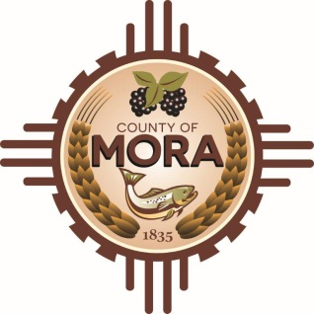

**Job Title: Receptionist**

This is Classified/Part-Time/Non-Exempt

**Position Summary:**

The County Receptionist serves as the first point of contact for visitors, and callers to the county office. This role plays a vital part in maintaining positive relationships with the public and providing essential administrative support to various departments within the county government.

**Essential Duties and Responsibilities:**

* Greet visitors in a friendly and professional manner.
* Answer incoming calls, transfer calls to appropriate department or individuals, and take messages, when necessary,
* Manager the flow of visitors and maintain a tidy reception area.
* Provide general information and assistance to visitors regarding county services, procedures, and regulations.
* Assist with administrative tasks such as typing, filing, photocopying, and data entry.
* Handle incoming and outgoing mail and packages.
* Schedule appointments, meetings, and conference rooms as needed.
* Respond to inquiries from the public in person, over the phone, and via email promptly and courteously.
* Direct individuals to the appropriate department or resource to address their needs.
* Handle complaints or concerns from the public with tact and professionalism, escalating issues as necessary.
* Liaise with various county departments to coordinate visitor’s appointments and provide necessary support.
* Work closely with other administrative staff to ensure smooth operations and efficient communication within the office.
* Adhere to all county policies and procedures related to confidentiality, security, and visitor access.
* Monitor visitors’ access and issue visitor badges as required.
* Maintain awareness of security protocols and report any suspicious activities or safety concerns to appropriate personnel.
* Performs other duties as required.

**Qualifications**

* High school diploma or equivalent; additional certification in office administration or relevant field is a plus.
* previous experience as a receptionist or administrative role preferred.
* Excellent communication and interpersonal skills.
* Proficiency in Microsoft Office (Word, Excel, Outlook). =
* Strong organizational skills and attention to detail.
* Ability to multitask and prioritize tasks in a fast-paced environment.
* Professional demeanor and customer service orientation.

**License Requirements:**

Valid New Mexico Driver’s License

**Acknowledgment:**

Employee’s Printed Name: _______________________________________________________

Signature: ____________________________________________________________________

Date: ___________________________

Supervisor’s Printed Name: ______________________________________________________

Signature: ____________________________________________________________________

Date: __________________________

Top of Form

Bottom of Form