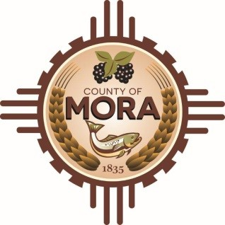

**Board of County Commissioners**

**Emergency Meeting**

**Wagon Mound High School/Administrative Board Room**

**State Road 120, Park Avenue**

**March 14, 2025**

**6:00 p.m.**

**MEETING NOTICE**

**Join Zoom Meeting**

Topic: Mora County Emergency Meeting

Time: Mar 14, 2025 06:00 PM Mountain Time (US and Canada)

Join Zoom Meeting

**Zoom Link: https://us06web.zoom.us/j/88180881771**

Meeting ID: 881 8088 1771

One tap mobile

+16694449171,,88180881771# US

+17193594580,,88180881771# US

The Mora County Board of Commission will hold an **Emergency Meeting** on Friday, March 14, 2025, at 6:00 p.m. at the Wagon Mound High School/Administrative Board Room. Agendas may be obtained at <https://towncloud.io/go/mora-county-nm/>

*If you are an individual with a disability who is in need of a reader, amplifier, qualified sign language interpreter, or any other form of auxiliary aid or service to attend or participate in the hearing or meeting, please contact the County Manager’s Office at the Mora County Courthouse at least one week prior to the meeting or as soon as possible. Public documents, including the agenda and minutes, can be provided in various accessible formats. Please contact the Mora County Managers Office at 575-387-5925 if a summary or other accessible format is needed.*

If you have difficulties connecting to Zoom, call the Manager’s Office at 575-387-5925

PUBLISH:

**Posted: Bulletin Board and County Website; 3-14-2025**