***Mora County Veterans Memorial Committee***

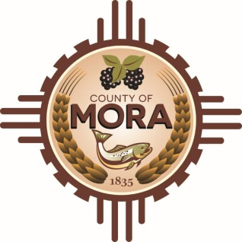

***Joe Gene Pacheco Max Garcia***

**ChairmanTreasurer**

***Harold Nolan Julian Olivas***

**Vice Chair Secretary**

**Veterans Memorial Committee**

**Mora Library**

**NM 518 Mora, NM 87732**

**March 11, 2025**

**1:00 p.m.**

**Agenda**

Zoom Meeting ID: 922 9093 4855

Passcode: 657464

Zoom Link: <https://zoom.us/j/92290934855?pwd=z9U70VyWOfoZCS3ZqT0vzdPf6NVALF.1>

Find your local number: <https://zoom.us/u/aelMMQ5M1>

1. Call to Order
2. Veterans Salute to the Flag of the United States of America
3. Approval of Agenda
4. Approval of Minutes
5. February 11, 2025
6. Discussion:
7. Memorial Budget Report- Max Garcia, Treasurer
8. Update by Larry Garcia
9. County Commission Meeting February 28, 2025
10. Meetings with Senator Campos & Representative Sanchez regarding Capital Outlay Request
11. Meeting with Architect Lloyd & Associates 2-21-25
12. Medals for Memorial Columns
13. Legislature-Recognition & Acknowledgment of Mora County Day February 20, 2025
14. Discussion/Action:
15. Veteran Memorial Committee Member Additions and/or Revisions.
16. Unfinished Business/Discussion:
17. New Business
18. Adjournment

If you are an individual with a disability who is need of a reader, amplifier, qualified sign language interpreter or any other form of auxiliary aid service to attend or participate in the meeting, please contact the Mora County Administration office located on Highway 518, 1 Courthouse Drive, Mora County Courthouse, Mora, New Mexico, as soon as possible at 575-387-5279.

Posted: Bulletin Board, County Website; 3-4-25