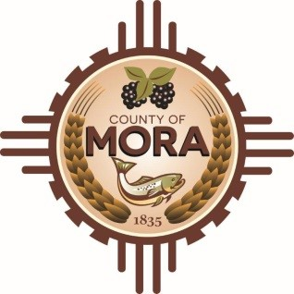

**Board of County Commissioners**

**Special Meeting**

**Mora Library (Dave F. Cargo Building)**

**335 NM 518 Mora, NM 87732**

**Wednesday, February 12, 2025**

**1:30 p.m.**

**MEETING NOTICE**

**Join Zoom Meeting**

Meeting ID: 999 6369 9950

Passcode: 265361

Zoom Link: <https://zoom.us/j/99963699950?pwd=EkmkbADJ4ZbwUfISd7W39im4bbCWnL.1>

Find your local number: <https://zoom.us/u/acTZyxTIXj>

The Mora County Board of Commission will hold a **Special Meeting** on Wednesday, February 12, 2025, at 1:30 p.m. at the Mora Library (Dave Cargo Building) in Mora, New Mexico. Agendas will be posted to the County’s Website at <https://towncloud.io/go/mora-county-nm/> by 1:30 p.m. on Sunday, February 9, 2025, and will be available for pick up at the County Manager’s Office during regular business hours on Monday, February 10, 2025.

*If you are an individual with a disability who is in need of a reader, amplifier, qualified sign language interpreter, or any other form of auxiliary aid or service to attend or participate in the hearing or meeting, please contact the County Manager’s Office at the Mora County Courthouse at least one week prior to the meeting or as soon as possible. Public documents, including the agenda and minutes, can be provided in various accessible formats. Please contact the Mora County Managers Office at 575-387-5925 if a summary or other accessible format is needed.*

If you have difficulties connecting to zoom, call the Manager’s Office at 575-387-5925

PUBLISH:

**Posted: Bulletin Board and County Website; 2-7-25**