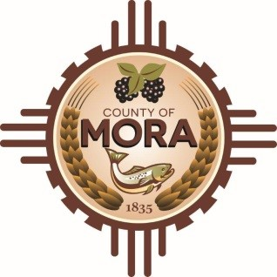

**Planning & Zoning Committee**

**Work Session**

**Mora Library**

**335 NM 518 Mora, NM 87732**

**March 5, 2025**

**9:00 a.m.**

**AGENDA**

**Join Zoom Meeting**

Meeting ID: 928 5781 6862

Passcode: 222717

Invite Link: <https://zoom.us/j/92857816862?pwd=dxRp6SfR0xkfzbQEo4N2SFyp0V1icf.1>

Find your local number: <https://zoom.us/u/abY8AURnCx>

1. **Call to Order**
2. **Pledge of Allegiance and Salute to the Flag of the State of New Mexico**

**3. Approval of Agenda**

1. **Discussion of DGS and 2018 MCZSR and possible revisions for Consideration at a Future Duly Noticed Planning and Zoning Committee Meeting**
2. **Adjournment**

*If you are an individual with a disability who is in need of a reader, amplifier, qualified sign language interpreter, or any other form of auxiliary aid or service to attend or participate in the hearing or meeting, please contact the County Manager’s Office at the Mora County Courthouse at least one week prior to the meeting or as soon as possible. Public documents, including the agenda and minutes, can be provided in various accessible formats. Please contact the Mora County Managers Office at 575-387-5925 if a summary or other accessible format is needed.*

If you have difficulties connecting to zoom, call the Manager’s Office at 575-387-5925

PUBLISH:

**Posted: Bulletin Board, and County Website; 2-28-25**