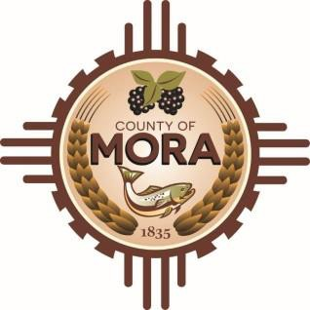

**NOTICE OF POSSIBLE QUORUM**

**Mora County Sheriff’s Office 1 Courthouse Drive**

**Friday, February 14, 2025, at 9:00 a.m.**

The Planning & Zoning Committee will be attending a training on Friday, February 15, 2025, at 9:00 a.m. at the Mora County Sheriff’s Office.

A possible quorum of the Mora County Commission and Planning and Zoning Committee may attend this meeting. No decisions will be made, or public policy formulated by the Commission or P&Z Committee members in attendance.

Notices of this type are not subject to the Open Meetings Act and instead are issued as a courtesy to the public.

Published: 2-14-25