***Mora County Veterans Memorial Committee***

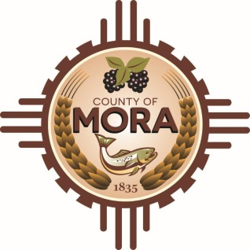

***Joe Gene Pacheco Max Garcia***

**ChairmanTreasurer**

***Harold Nolan Julian Olivas***

**Vice Chair Secretary**

**Veterans Memorial Committee**

**Mora Library**

**NM 518 Mora, NM 87732**

**February 11, 2025**

**1:00 p.m.**

**Agenda**

Zoom Meeting ID: 922 9093 4855

Passcode: 657464

Zoom Link: <https://zoom.us/j/92290934855?pwd=z9U70VyWOfoZCS3ZqT0vzdPf6NVALF.1>

Find your local number: <https://zoom.us/u/aelMMQ5M1>

1. Call to Order
2. Veterans Salute to the Flag of the United States of America
3. Approval of Agenda
4. Approval of Minutes
5. January 14, 2025
6. January 22, 2025
7. Discussion/Presentation: Update from Tom Cordova, Lloyd & Associates Architect
8. Discussion/Presentation: Joseph Griego-Chicanos Por La Causa Program
9. Discussion:
10. Update by Larry Garcia-County Commission meeting January 24, 2025
11. Unfinished Business/Discussion:
12. Meeting with Representative Joseph Sanchez
13. Mora Day at Legislature February 2025
14. Betty Griego-Update on Brochure (Veteran’s Memorial) and Planning
15. Memorial Banner Discussion
16. New Business
17. Adjournment

If you are an individual with a disability who is need of a reader, amplifier, qualified sign language interpreter or any other form of auxiliary aid service to attend or participate in the meeting, please contact the Mora County Administration office located on Highway 518, 1 Courthouse Drive, Mora County Courthouse, Mora, New Mexico, as soon as possible at 575-387-5279.

Posted: Bulletin Board, County Website; 2-4-25