***Mora County Veterans Memorial Committee***

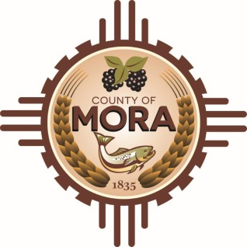

***Joe Gene Pacheco Max Garcia***

**ChairmanTreasurer**

***Harold Nolan Julian Olivas***

**Vice Chair Secretary**

**Veterans Memorial Committee**

**Mora Library**

**NM 518 Mora, NM 87732**

**January 22, 2025**

**1:00 p.m.**

**Agenda**

Zoom Meeting ID: 819 7120 6359

Passcode: 728171

Zoom Link: <https://us02web.zoom.us/j/81971206359?pwd=TJynvtmQ6dMlP3MLBIx9HLQMQZcteM.1>

Find your local number: <https://us02web.zoom.us/u/kcuvVoSBQz>

1. Call to Order
2. Veterans Salute to the Flag of the United States of America
3. Approval of Agenda
4. Discussion/Action: Approval of Mora County Veterans Memorial Construction Documents by Committee
5. Unfinished Business
6. New Business
7. Adjournment

If you are an individual with a disability who is need of a reader, amplifier, qualified sign language interpreter or any other form of auxiliary aid service to attend or participate in the meeting, please contact the Mora County Administration office located on Highway 518, 1 Courthouse Drive, Mora County Courthouse, Mora, New Mexico, as soon as possible at 575-387-5279.

Posted: Bulletin Board, County Website; 1-15-25