***Mora County Veterans Memorial Committee***

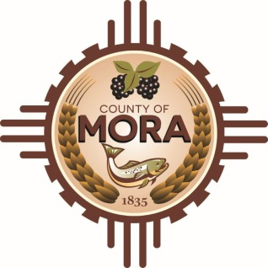

***Joe Gene Pacheco Max Garcia***

**ChairmanTreasurer**

***Harold Nolan Julian Olivas***

**Vice Chair Secretary**

**Veterans Memorial Committee**

**NM 518 David Cargo Library**

**January 14, 2025**

**1:00 p.m.**

**Agenda**

Zoom Meeting ID: 922 9093 4855

Passcode: 657464

Zoom Link: <https://zoom.us/j/92290934855?pwd=z9U70VyWOfoZCS3ZqT0vzdPf6NVALF.1>

Find your local number: <https://zoom.us/u/aelMMQ5M1>

1. Call to Order
2. Veterans Salute to the Flag of the United States of America
3. Approval of Agenda
4. Approval of Minutes
5. November 19, 2024
6. December 10, 2024
7. Discussion/Action:

Update and Approval of construction documents-Tom Cordova, Architect with Lloyd & Associates.

1. Discussion/Presentation:

Joseph Griego-Chicanos Por La Causa Program

1. Discussion:
2. Update by Larry Garcia-County Commission meeting December 24, 2024.
3. Update by Larry Garcia & Julian Olivas-Meeting with Mora Creative Council December 12, 2024.
4. Unfinished Business
5. New Business
6. Adjournment

If you are an individual with a disability who is need of a reader, amplifier, qualified sign language interpreter or any other form of auxiliary aid service to attend or participate in the meeting, please contact the Mora County Administration office located on Highway 518, 1 Courthouse Drive, Mora County Courthouse, Mora, New Mexico, as soon as possible at 575-387-5279.

Posted: Bulletin Board, County Website; 1-8-25