Dec. 20 Deadline Social Media Drafts for Federal, State and Private Partners
A repository of new and existing social media posts for federal, state, and private partners to use to help amplify the Dec. 20 deadline to submit a Notice of Loss.

December 20 Social Media Posts: Other Federal, State, and Private Partners
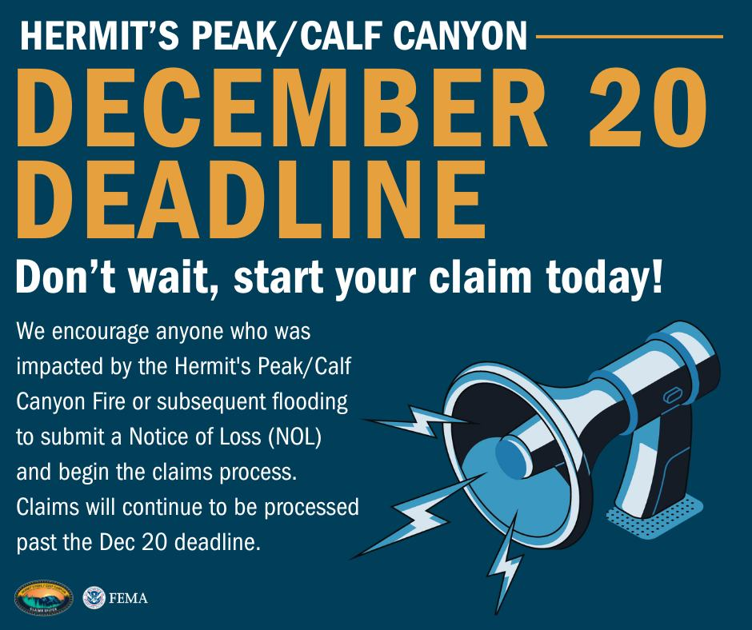
**URGENT REMINDER – 11:59pm, December 20 Deadline for Notice of Loss Submissions - Hermit’s Peak/Calf Canyon Fire**
We want to remind all those who have been impacted by the Hermit’s Peak/Calf Canyon fire that the deadline to submit a Notice of Loss (NOL) is 11:59pm, December 20, 2024. This is the last chance to ensure you receive the compensation you are owed for any losses or damages resulting from the fire. Claims will continue to be processed and paid out after the December 20 deadline.
What You Need to Do:
- Don’t wait - Submit a NOL today!
- Gather all necessary documentation - The NOL form collects claimant contact information, a general description of losses, and information about other benefits such as insurance, grants or loans.
- Need help? Visit https://www.fema.gov/disaster/current/hermits-peak or call the Claims Office Helpline at (505) 995-7133.
Don’t miss out on the opportunity to receive the support you may need for recovery or the compensation you are owed. Time is running out!
#FEMA #CommunitySupport #HermitsPeakCalfCanyon #FireRecovery
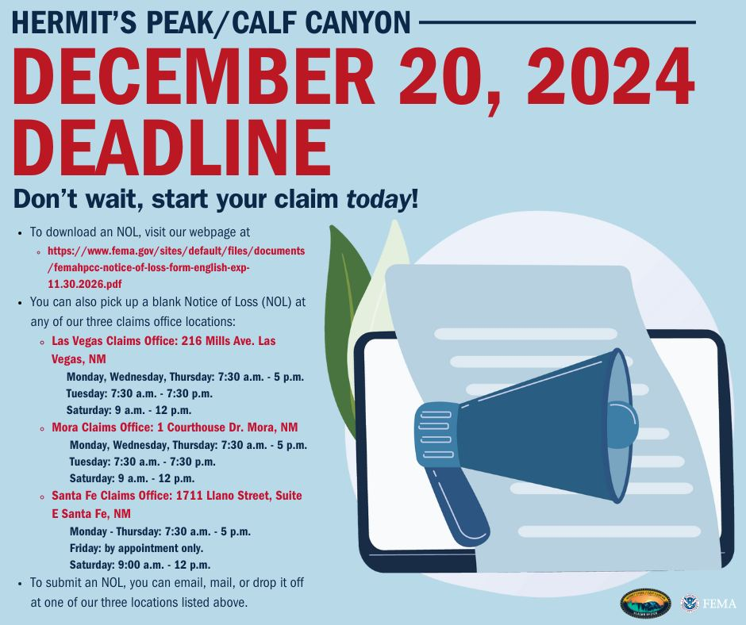
**REMINDER: 11:59pm, December 20 Deadline to Submit a Notice of Loss - Hermit’s Peak/Calf Canyon Fire**
We want to help ensure that those impacted by the Hermit’s Peak/Calf Canyon fire don’t miss the December 20, 2024 deadline to submit a Notice of Loss (NOL) to the Claims Office. Claims submitted by that date will continue to be processed and paid out after the December 20 deadline.
Key Next Steps:
Submit a NOL via mail, email, or in person - Late submissions will not be eligible for compensation from the Claims Office.
- To mail a NOL, individuals should use the following address with a postmark of and by 11:59pm, Dec. 20, 2024: FEMA Hermit’s Peak/Calf Canyon Claims Office, P.O. Box 1329, Santa Fe, NM 87504.

- To email a NOL, individuals should use the following email address, and it must be received by 11:59pm on Dec. 20, 2024, to: fema-hermits-peak@fema.dhs.gov

- To submit a NOL in person, individuals may do so at any of our three claims office locations as all of our three offices will be open till 11:59pm on Dec. 20, 2024. Please visit our webpage for-office locations and general operating hours.
- Discussions with your FEMA assigned Navigator – will include all necessary documentation to support your claim and verify damages
- Need Help? Visit https://www.fema.gov/disaster/current/hermits-peak or call the Claims Office Helpline at (505) 995-7133.
Don’t wait! Act today to ensure your eligibility for support in your recovery process! Time is running out!
#FEMA #DisasterAssistance #HermitsPeakCalfCanyon #NoticeofLoss #CommunitySupport
Repost Directly from the Claims Office Facebook Page
In addition to the Social Media draft content above, partners can share posts directly from the Claims Office Facebook page. Below is a list of recent Facebook posts related to the Dec. 20 deadline:
- Claims Office Social Media Deadline Extension
- Claims Office Social Media NOL Submissions for Deadline
- Claims Office Social Media Business Claim Deadline
- Claims Office Social Media Did You Know Deadline Graphic
- Claims Office Social Media Agriculture Claim Deadline
- Claims Office Social Media NFIP Deadline Extension
- Claims Office Social Media Deadline Reminder
- Claims Office Social Media Deadline Reminder
- Claims Office Social Media 20 Days to Deadline
- Claims Office Social Media Deadline Cover Graphic

