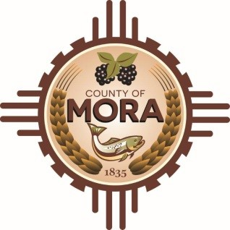

**Board of County Commissioners**

**Special Meeting**

**Mora Independent School District Board Room**

**10 Ranger Rd, Mora, NM 87732**

**Wednesday November 6, 2024**

**4:00 p.m.**

**MEETING NOTICE**

**MEETING CANCELLATION NOTICE:**

**Due to inclement weather, the meeting noticed herein is cancelled and will be rescheduled for Tuesday, November 12, 2024, at 9:00 a.m. at the David F. Cargo Library, [insert address], Mora, New Mexico.**

***The updated agenda will be posted to the County’s website no later***

***than Friday, November 8, 2024, at 4:00 p.m.***

**Join Zoom Meeting**

Meeting ID: 873 9121 2143

Passcode: 330439

Zoom Link: <https://us06web.zoom.us/j/87391212143?pwd=ozJnBCPKojLp0gPSuYzyZw5xYREJga.1>

Find your local number: <https://us06web.zoom.us/u/kBS6OqdwW>

The Mora County Board of Commission will hold a **Special Meeting** on Wednesday November 6, 2024, at 4:00 p.m. at the Mora Independent School District Board Room Mora, New Mexico. Agendas may be obtained at the Mora County Manager’s Office on Friday November 1, 2024, at 4:00p.m. or at <https://towncloud.io/go/mora-county-nm/>

*If you are an individual with a disability who is in need of a reader, amplifier, qualified sign language interpreter, or any other form of auxiliary aid or service to attend or participate in the hearing or meeting, please contact the County Manager’s Office at the Mora County Courthouse at least one week prior to the meeting or as soon as possible. Public documents, including the agenda and minutes, can be provided in various accessible formats. Please contact the Mora County Managers Office at 575-387-5925 if a summary or other accessible format is needed.*

If you have difficulties connecting to zoom, call the Manager’s Office at 575-387-5925.

PUBLISH:

**Posted: Bulletin Board, and County Website; 10-31-24**

**Cancellation Notice: Posted on 11/6/2024**