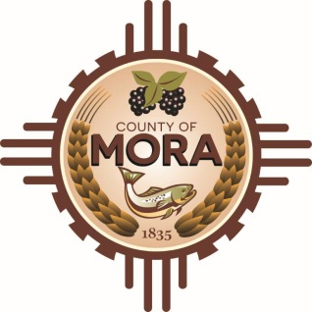

**Job Title: Emergency Technician-Paramedic**

This is Classified/Full-Time/Non-Exempt/$20.00

**Position Summary:**

Emergency Medical Technician-Paramedic must have four to six years of relevant experience in the EMS field. Including BLS, ACLS, and NREMT- Paramedic certification. This entails between 1200 and 1800 hours of specialized training, as well as CPR Certification. Must demonstrate competency in handling emergencies. Providing life support and advanced life support equipment and skill in accordance with the New Mexico curriculum of EMT-Paramedic as identified by the New Mexico current scope of practice and EMS treatment guidelines.

**Essential Duties and Responsibilities:**

* Functions within the scope of practice for licensure as defined by National and State Guidelines.
* Understand advanced medical-legal principles.
* Receive and respond to emergency calls.
* Has a basic understanding of equipment and other devices and procedures as authorized by the level of licensure and scope of practice for EMT-Paramedic.
* Assist in lifting, carrying, and transporting patients to an appropriate medical center.
* Must be knowledgeable in extrication, wound care, and advanced life support treatments.
* Enter all service reports into NIMS within 24 hours of treatment.
* Follow the directives given by the Service Medical Director.
* Follow training protocols/continuing Education.
* Performs other duties as required.

The EMT-P will determine the nature and extent of illness or injury and establish priority for required emergency care. Duties include but are not limited to:

* Utilize Paramedic skills on medical equipment and procedures including Medications, Defibrillator, EKG Monitor, Oxygen, Suction devices, and intravenous fluids to provide advanced medical care and prehospital treatment.
* In the event of disaster or emergency, the state EMS medical Director or Chief Medical officer for the Department of Health may temporarily authorize the administration of other immunizations, vaccines, biological or test not listed.

**License Requirements:**

Valid New Mexico Driver’s License

Required Certification as EMT-P. BLS, ACLS, NREMT-P

American Heart Association Healthcare Provider CPR

Fingerprinted Background Check EMS Bureau

Four to Six years of relevant experience In the EMS Field

**Declaration:**

I have read the above position requirements and position description. I understand the demands and expectations of the position described and, to the best of my knowledge, believe that I can perform these duties.

Employee’s Printed Name: _______________________________________________________

Signature: ____________________________________________________________________

Date: ___________________________

Supervisor’s Printed Name: ______________________________________________________

Signature: ____________________________________________________________________

Date: __________________________

Top of Form

Bottom of Form