***Mora County Veterans Memorial Committee***

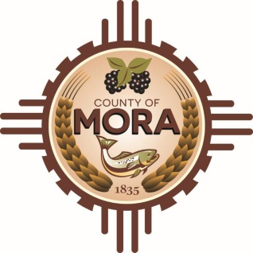

***Joe Gene Pacheco Max Garcia***

**ChairmanTreasurer**

***Harold Nolan Julian Olivas***

**Vice Chair Secretary**

**Veterans Memorial Committee**

**NM 518 David Cargo Library**

**October 8, 2024**

**1:00 p.m.**

**Agenda**

Zoom Meeting ID: 862 7868 5150

Passcode: 489579

Zoom Link: <https://us06web.zoom.us/j/86278685150?pwd=nrUOgnK72tHRbqx8aZdPfMojxO5or3.1>

Find your local number: Find your local Number: <https://us06web.zoom.us/u/kBS6OqdwW>

1. Call to Order
2. Veterans Salute to the Flag of the United States of America
3. Approval of Agenda
4. Approval of Minutes
5. August 13, 2024
6. September 10, 2024
7. Discussion/Action
8. Approving request to the County Commission allowing the Mora County Veteran’s Committee to work with Mora Creative Council’s Veteran Committee to initiate a fundraising initiative involving pavers/bricks for placement at the Mora County Veteran’s Memorial.
9. Discussion/Action

Update on Memorial plans and timelines by Tom Cordova, Architect with Lloyd & Associates.

1. Discussion/Action

Plan activities with Mora Schools on Veteran’s Day.

1. Discussion/Action

Logo permission release by Tony Garcia.

1. Discussion

Update by Larry Garcia-County Commission Meeting on September 23, 2024.

1. Unfinished Business/Discussion
2. Max Garcia contact with VFW, VFW Auxiliary and American Legion on volunteers for Fund Raising.
3. Max Garcia-Quote for Mora/Taos revolt plaque.
4. Jim Cassidy-Details on brick engraving and process
5. New Business
6. Adjournment

If you are an individual with a disability who is need of a reader, amplifier, qualified sign language interpreter or any other form of auxiliary aid service to attend or participate in the meeting, please contact the Mora County Administration office located on Highway 518, 1 Courthouse Drive, Mora County Courthouse, Mora, New Mexico, as soon as possible at 575-387-5279.

Posted: Bulletin Board, County Website; 10-1-24