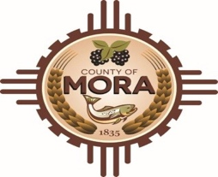

**Board of County Commissioners**

**Regular Meeting (Recessed on September 23, 2024)**

**Mora Independent School District Board Room**

**10 Ranger Rd, Mora, NM 87732**

**Tuesday, September 24, 2024**

**1:00 P.M.**

**(**Meeting recessed on Monday September 23, 2024**)**

**MEETING NOTICE**

**Join Zoom Meeting**

Meeting ID: 821 0977 5604

Passcode: 219085

Zoom Link:

https://us06web.zoom.us/j/82109775604?pwd=Dhb79UTKcWBsY8qcIBgbrO44IU0IlD.1

Find your local number: <https://us06web.zoom.us/u/kBS6OqdwW>

If you have difficulties connecting to zoom, call the Manager’s Office at 575-387-5925

The Mora County Board of Commission will resume a recessed **Regular Meeting** (commenced on Monday September 23, 2024, at 4:10 p.m.) and to be resumed on Tuesday September 24, 2024, at 1:00 p.m. at the Mora Independent School District Board Room Mora, New Mexico. Agendas are available at the Manager’s Office or on <https://towncloud.io/go/mora-county-nm/> as previously posted on September 20, 2024, at 8:46 a.m.

*If you are an individual with a disability who is in need of a reader, amplifier, qualified sign language interpreter, or any other form of auxiliary aid or service to attend or participate in the hearing or meeting, please contact the County Manager’s Office at the Mora County Courthouse at least one week prior to the meeting or as soon as possible. Public documents, including the agenda and minutes, can be provided in various accessible formats. Please contact the Mora County Managers Office at 575-387-5925 if a summary or other accessible format is needed.*

PUBLISH:

**Posted: Bulletin Board, and County Website; 9-23-24**