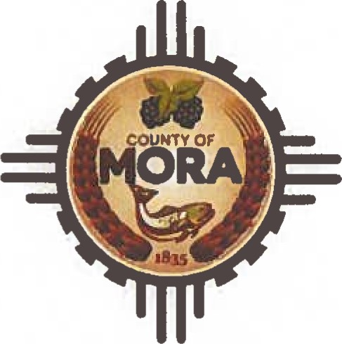County Commissioners

George Trujillo

Commission Chair

Johnny Trujillo

Commission Vice-Chair

Veronica Serna

Member

# INVITATION TO BID (ITB)

|  |  |  |
| --- | --- | --- |
| ITB Number | | ITB 02-2024 |
| ITB Name | | Invitation to Bid for Propane for Volunteer Fire Departments |
| Date Issued | | September 13, 2024 |
| Published | | Mora County Website  Santa Fe New Mexican, Friday September 13, 2024 |
| Contact Person | | Adelita Encinias, Procurement Officer |
| Contact Info | | Ph:575-387-5279 Email: aencinias@countyofmora.com |
| Submittal Accepted Until | | September 27, 2024 @ IO: OOAM |
| Public Opening of Bid to be held on | | September 30, 2024 @ 8:00AM in the Finance Office |
| Purpose of ITB | Mora County is requesting Bids for Purchase of Propane for Mora County. | |
| Specifications | The County of Mora Fire Services require heated facilities to house its firefighting apparatus and equipment. Therefore, the County of Mora (hereafter “the County”) seeks bids from qualified vendors for the following propane services at all Mora County Fire Stations: (1) supply propane to all listed fire stations and sites, (2) provide gas appliance maintenance and repair services (on an emergency basis when required) to all fire stations and locations.  LOCATIONS  Chacon Fire Department  CR B-007  MM 6 State Highway 121  CHET Fire Department  3 CR B-028  MM 32.1  CHET Sub Station  21 State Highway 121  MM.2  Mora Fire Department  602 State Highway 518  MM 30.5  LMC Main Station  1398 State Highway 518  MM 13.9  LMC Sub Station  90 CR A-005  MM 16.3-State Highway 94  Buena Vista  95 CR C-001  MM 21.8 State Highway 518  Golondrinas  565 Highway 61  MM 5.6 | |

|  |  |
| --- | --- |
| Advertisement Dates | ITB 02-2024  Invitation to Bid for Purchase Of 14-Yard Dump Truck  Website Date: Friday, September 13, 2024  PUB: Santa Fe New Mexican Friday, September 13, 2024  Bulletin Board Date: September 13, 2024  Last Day to Submit Bid Questions: September 20, 2024 @8:00am  Public Opening: September 30th, 2024, at 8:00am in the  Finance Office |

|  |  |
| --- | --- |
| Submittal  Procedures | Proposers shall submit Bid by the date and time indicated below.  Due by: September 27th at 10:00 am  Proposals not submitted by that will be returned unopened. Proposals shall not be valid unless sealed in a single envelope marked:  "INVITATION TO BID FOR PURCHASE OF PROPANE”  Attention: Adelita Encinias, Chief Procurement Officer  I Courthouse Drive  P.O. Box 580  Mora, New Mexico 87732  "DO NOT OPEN" |