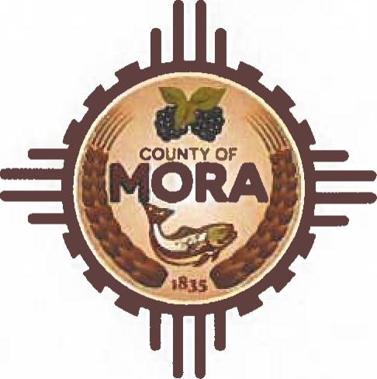County Commissioners

George Trujillo

Commission Chair

Johnny Trujillo

Commission Vice-Chair

Veronica Serna

Member

INVITATION TO BID (ITB)

|  |  |  |
| --- | --- | --- |
| ITB Number | | ITB 2024-002 |
| ITB Name | | Invitation to Bid for Pit Run Material |
| Date Issued | | September 13, 2024 |
| Published | | Mora County Website |
| Contact Person | | Adelita Encinias, Procurement Officer |
| Contact Info | | Ph:575-387-5279 Email: aencinias@countyofmora.com |
| Submittal Accepted Until | | September 27, 2024 @ 1O: OOAM |
| Public Opening of Bid to be held on | | September 30, 2024 @ 8:00AM in the Finance Office |
| Purpose of ITB | Mora County is issuing an Invitation to Bid Road Pit Run Material | |
| Project Goals  & Objectives | Applicants must have a business license in the State of New  Mexico, as well as a Mora County Business License. | |

|  |  |
| --- | --- |
| Scope of Work | Mora County is requesting Bids for Pit Run Material. The Bid shall be submitted in price per yard. The County shall be responsible for loading and transporting said Pit Run Material. The County shall be responsible for stockpiling of material needed for the County. The Contractor shall permit authorized County employees’ reasonable access to the material during normal business hours (8:00am-4:30pm) and after business hours, if necessary. The location of the material shall be available for inspection by the County Manager, or his designee. Mora County reserves the right to refuse any material that is deemed unacceptable by the County. |

|  |  |
| --- | --- |
| Submittal  Procedures | Proposers shall submit Bid by the date and time indicated below.  Due by: September 27th at 10:00 am  Proposals not submitted by that will be returned unopened. Proposals shall not be valid unless sealed in a single envelope marked:  "Invitation to Bid for Pit Run Material"  Attention: Adelita Encinias, Chief Procurement Officer  I Courthouse Drive  P.O. Box 580  Mora, New Mexico 87732  "DO NOT OPEN" |
| Advertisement Dates | Invitation to Bid  ITB 2024-002- Invitation to Bid for Road Pit Run Material  Website Date: Friday, September 13, 2024  PUB: Santa Fe New Mexican Friday, September 13, 2024  Bulletin Board Date: September 13, 2024  Last Day to Submit Bid Questions: September 20, 2024, at Public Opening: September 30th, 2024 at 8:00am in the  Finance Office |