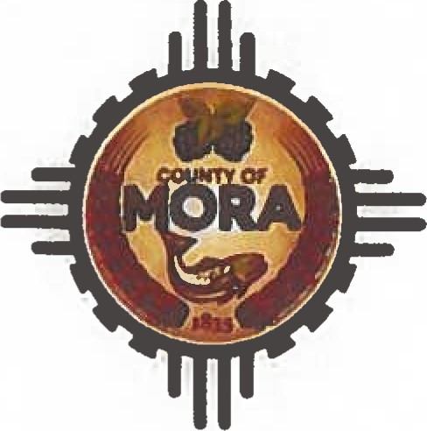County Commissioners

George Trujillo

Commission Chair

Johnny Trujillo

Commission Vice-Chair

Veronica Serna Member

INVITATION TO BID (ITB)

|  |  |  |
| --- | --- | --- |
| ITB Number | | ITB 02-2024 |
| ITB Name | | INVITATION TO BID FOR PURCHASE OF 14-YARD DUMP TRUCK |
| Date Issued | | September 13, 2024 |
| Published | | Mora County Website  Santa Fe New Mexican,  Friday September 13,  2024 |
| Contact Person | | Adelita Encinias, Procurement Officer |
| Contact Info | | Ph:575-387-5279 Email:  aencinias@countyofmora.com |
| Submittal Accepted Until | | September 27, 2024 @ IO:OOAM |
| Public Opening of Bid to be held on | | September 30, 2024 @ 9:00AM in the Finance  Office |
| Purpose of ITB | Mora County is looking for a Used Heavy Duty 14-yd Dump Truck | |

|  |  |  |  |
| --- | --- | --- | --- |
| Specifications | | Like or Equal to:  Truck Chassis 2016 or Newest  Engine: 450 HP+  Transmission: 10 Speed+/Manual Transmission  Tires & Wheels: New Tires  Fuel Tank: 100-Gallon Fuel Tank Capacity  Dump Body  Electric Tarp System | |
| Advertisement  Dates | | ITB 02-2024  Invitation to Bid for Purchase Of 14-Yard Dump Truck  Website Date: Friday, September 13, 2024  PUB: Santa Fe New Mexican Friday,  September 13, 2024  Bulletin Board Date: September 13, 2024  Last Day to Submit Bid Questions: September 20, 2024 @8:00am  Public Opening: September 30th, 2024, at 8:00am in the Finance Office | |

|  |  |
| --- | --- |
| Submittal  Procedures | Proposers shall submit Bid by the date and time indicated below.  Due by: September 27th at 10:00 am  Proposals not submitted by that will be returned unopened. Proposals shall not be valid unless sealed in a single envelope marked:  "INVITATION TO BID FOR PURCHASE OF 14-YARD DUMP TRUCK"  Attention: Adelita Encinias, Chief Procurement Officer  I Courthouse Drive  P.O. Box 580  Mora, New Mexico 87732  "DO NOT OPEN" |