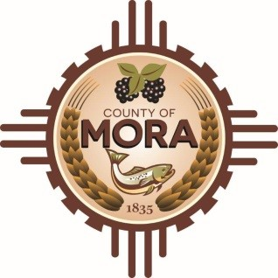

**Board of County Commissioners**

**ICIP Work Session**

**Mora Independent School District Board Room**

**10 Ranger Rd, Mora, NM 87732**

**Tuesday September 17, 2024**

**10:00 a.m.**

**MEETING NOTICE**

**Join Zoom Meeting**

Meeting ID: 844 7500 7290

Passcode: 501661

Zoom Link: <https://us06web.zoom.us/j/84475007290?pwd=1pjatsXEW8ddDahAjUAFMPdUbRtdZp.1>

Find your local number: <https://us06web.zoom.us/u/kBS6OqdwW>

The Mora County Board of Commission will hold an **ICIP** **Work Session** on Tuesday September 17, 2024, at 10:00 a.m. at the Mora Independent School District Board Room Mora, New Mexico. Agendas may be obtained on Friday September 6, 2024 or at <https://towncloud.io/go/mora-county-nm/>

*If you are an individual with a disability who is in need of a reader, amplifier, qualified sign language interpreter, or any other form of auxiliary aid or service to attend or participate in the hearing or meeting, please contact the County Manager’s Office at the Mora County Courthouse at least one week prior to the meeting or as soon as possible. Public documents, including the agenda and minutes, can be provided in various accessible formats. Please contact the Mora County Managers Office at 575-387-5925 if a summary or other accessible format is needed.*

If you have difficulties connecting to zoom, call the Manager’s Office at 575-387-5925

PUBLISH:

**Posted: Bulletin Board, and County Website; 9-6-24**