***Mora County Veterans Memorial Committee***

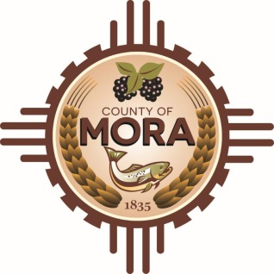

***Joe Gene Pacheco Max Garcia***

**ChairmanTreasurer**

***Harold Nolan Julian Olivas***

**Vice Chair Secretary**

**Veterans Memorial Committee**

**1 Courthouse Drive Mora, NM**

**September 10, 2024**

**1:00 p.m.**

**Agenda**

Zoom Meeting ID: 862 7868 5150

Passcode: 489579

Zoom Link: <https://us06web.zoom.us/j/86278685150?pwd=nrUOgnK72tHRbqx8aZdPfMojxO5or3.1>

Find your local number: Find your local Number: <https://us06web.zoom.us/u/kBS6OqdwW>

1. Call to Order
2. Veterans Salute to the Flag of the United States of America
3. Approval of Agenda
4. Approval of Minutes
5. August 13, 2024
6. Discussion/Action
7. Sub-Committee-update—Julian, Jo Gene, & Larry Meeting with Architects (8-28-24)
8. Define/Outline Construction Assemblies
9. Unfinished Business
10. New Business
11. Adjournment

If you are an individual with a disability who is need of a reader, amplifier, qualified sign language interpreter or any other form of auxiliary aid service to attend or participate in the meeting, please contact the Mora County Administration office located on Highway 518, 1 Courthouse Drive, Mora County Courthouse, Mora, New Mexico, as soon as possible at 575-387-5279.

Posted: Bulletin Board, County Website; 9-6-24