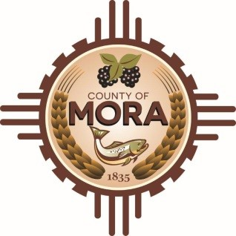

NOTICE OF CLOSURE

AUGUST 29,2024

MORA COUNTY SOLID WASTE WILL BE CLOSING AT 12:00 (NOON)

TILL 4:30 PM

WILL RESUME NORMAL HOURS ON FRIDAY AUGUST 30,2024.

THANK YOU FOR UNDERSTANDING. 