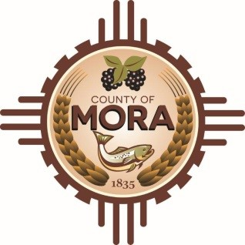

NOTICE OF CLOSURE

AUGUST 29,2024

MORA COUNTY OFFICES WILL BE CLOSING AT 12:00 P.M. IN OBSERVANCE OF EMPLOYEE APPRECIATION DAY

COUNTY OFFICES WILL RESUME BUSINESS HOURS ON TUESDAY SEPTEMBER 3 ,2024 8:00 A.M. TO 4:30 P.M.