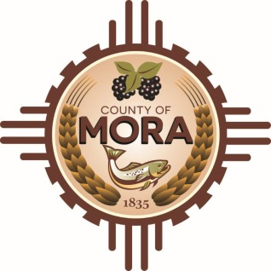

**Job Title: Solid Waste Director**

This is Classified/Full-Time/Non-Exempt

**Position Summary:**

The Solid Waste Director is responsible for overseeing and managing all aspects of the county's solid waste management operations, including collection, disposal, and recycling. This role involves strategic planning, regulatory compliance, budget management, and public outreach to ensure efficient and environmentally responsible waste management services for the community. The Solid Waste Director will lead a team of professionals and collaborate with various stakeholders to achieve the county's waste management goals.

**Essential Duties and Responsibilities:**

* Develop and implement long-term strategic plans for solid waste management, including waste reduction, recycling, and sustainable disposal practices.
* Establish goals, objectives, and performance metrics to improve the efficiency and effectiveness of waste management operations.
* Conduct regular assessments of waste management programs and services to identify areas for improvement.
* Oversee the daily operations of solid waste collection, transportation, disposal, and recycling programs.
* Ensure compliance with local, state, and federal regulations related to waste management and environmental protection
* Manage contracts with waste haulers, landfill operators, recycling facilities, and other service providers
* Develop and manage the department's annual budget, including forecasting revenue and expenses.
* Identify opportunities for cost savings and revenue generation within the solid waste management operations
* Foster a positive and productive work environment, promoting teamwork and professional development.
* Conduct performance evaluations and implement improvement plans as needed.
* Develop and implement public outreach and education programs to promote waste reduction, recycling, and proper disposal practices
* Represent the department at public meetings, community events, and other forums to engage with residents and stakeholders
* Respond to inquiries, complaints, and service requests from the public and other entities.
* Ensure all waste management activities comply with environmental regulations and sustainability principles
* Implement and promote waste diversion and recycling initiatives to reduce landfill use and environmental impact
* Collaborate with other departments and agencies on environmental and sustainability projects
* Establish and implement quality assurance processes to ensure project deliverables meet established standards and requirements
* Conduct post-project evaluations to assess outcomes, identify lessons learned, and recommend improvements for future projects
* Ensure all projects comply with relevant laws, regulations, and county policies
* Identify potential risks and develop mitigation strategies to minimize impact on project success
* Maintain comprehensive project documentation and records
* Performs other duties as required.

**Skills and Competencies:**

* Strong project management skills, including planning, execution, and monitoring.
* Excellent communication and interpersonal skills, with the ability to effectively interact with diverse stakeholders.
* Proficiency in project management software and tools.
* Strong analytical and problem-solving abilities
* Ability to manage multiple projects simultaneously and prioritize tasks effectively**.**
* Ability to work independently and as part of a team.

**Working Conditions:**

* Office environment with travel to projects sites and meetings.
* May require extended hours during project periods.

**Qualifications**

* Bachelor's degree in Environmental Science, Public Administration, Business Administration, or a related field. A Master's degree is preferred.
* Minimum of 7 years of experience in solid waste management, including at least 3 years in a supervisory or managerial role.

**License Requirements:**

Valid New Mexico Driver’s License

**Acknowledgment:**

Employee’s Printed Name: _______________________________________________________

Signature: ____________________________________________________________________

Date: ___________________________

Supervisor’s Printed Name: ______________________________________________________

Signature: ____________________________________________________________________

Date: __________________________

Top of Form

Bottom of Form