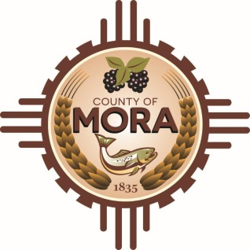

**Job Title: Planner and Rural Addressing Technician**

This is Classified/Full-Time/Non-Exempt

**Position Summary:**

The Planner and Rural Addressing Technician plays a vital role in organizing and optimizing rural transportation routes while ensuring accurate addressing for efficient delivery and emergency response services. This position involves analyzing geographic data, designing effective routes, and maintaining precise addressing databases in rural areas.

**Essential Duties and Responsibilities:**

* Analyze geographic data, topographic maps, and aerial imagery to identify and map rural areas accurately.
* Collaborate with local government agencies, emergency services, and postal authorities to understand addressing requirements and standards.
* Develop and maintain accurate addressing databases for rural communities, including assigning addresses to new properties and verifying existing addresses.
* Design efficient transportation routes for rural areas, considering factors such as road conditions, terrain, and population density.
* Utilize geographic information systems (GIS) and route optimization software to plan and update rural routes.
* Conduct field surveys to verify addressing information, assess road conditions, and identify potential route improvements.
* Coordinate with stakeholders to resolve addressing discrepancies and ensure compliance with addressing standards.
* Provide technical support and training to field staff and community members on addressing procedures and GIS tools.
* Monitor route performance and recommend adjustments to improve efficiency and response times.
* Stay informed about changes in addressing regulations and best practices for rural addressing.
* Performs other duties as required.

**Qualifications**

* Previous experience in rural planning, GIS analysis, or addressing management is advantageous.
* Strong understanding of rural geography, including land use patterns and transportation networks
* Excellent analytical and problem-solving skills
* Attention to detail and accuracy in data management.
* Knowledge of addressing standards and regulations, including E-911 requirements, is desirable.

**License Requirements:**

Valid New Mexico Driver’s License

**Acknowledgment:**

Employee’s Printed Name: _______________________________________________________

Signature: ____________________________________________________________________

Date: ___________________________

Supervisor’s Printed Name: ______________________________________________________

Signature: ____________________________________________________________________

Date: __________________________

Top of Form

Bottom of Form