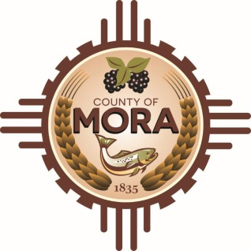

**Job Title: Code Enforcement/Compliance Officer**

This is Classified/Full-Time/Non-Exempt

**Position Summary:**

The Code Enforcement/Compliance Officer is responsible for ensuring compliance with municipal codes, zoning regulations, and ordinances to promote public health, safety, and welfare. This position involves inspecting properties, investigating complaints, and enforcing regulations related to building codes, property maintenance, land use, and environmental health.

**Essential Duties and Responsibilities:**

* Conduct routine inspections of properties to identify violations of building codes, zoning regulations, and other ordinances.
* Respond to complaints from residents, businesses, and other stakeholders regarding potential code violations.
* Investigate reported violations, gather evidence, and document findings in accordance with established procedures.
* Notify property owners, tenants, and responsible parties of violations and educate them on compliance requirements and corrective actions.
* Work collaboratively with property owners, contractors, and other stakeholders to achieve voluntary compliance with regulations.
* Issue warnings, citations, or notices of violation as necessary to enforce compliance with municipal codes and ordinances.
* Document inspection results, enforcement actions, and correspondence in written reports and electronic databases.
* Coordinate with other municipal departments, agencies, and legal authorities to address complex or persistent code enforcement issues.
* Participate in court proceedings, administrative hearings, and other enforcement actions as a witness or representative of the municipality.
* Stay informed about changes in laws, regulations, and best practices related to code enforcement and compliance.

**Qualifications**

* High school diploma or equivalent; associate’s or bachelor’s degree in criminal justice, public administration, urban planning, or related field preferred.
* Previous experience in code enforcement, compliance, law enforcement, or related field is advantageous.
* Knowledge of building codes, zoning regulations, property maintenance standards, and municipal ordinances
* Familiarity with legal procedures, investigative techniques, and enforcement practices.
* Excellent communication skills, both verbal and written
* Strong interpersonal skills and ability to work effectively with diverse stakeholders.
* Attention to detail and ability to document inspection findings accurately.
* Ability to handle sensitive or confrontational situations professionally and tactfully.
* Proficiency in using computers and software applications for data entry, report writing, and communication.
* Ability to prioritize tasks, work under pressure, and meet deadlines.
* Customer service-oriented with the ability to interact professionally with the public and stakeholders.
* Knowledge of local government operations and procedures is desirable.
* A willingness to learn and adapt to changing responsibilities and priorities.

**License Requirements:**

Valid New Mexico Driver’s License

**Acknowledgment:**

Employee’s Printed Name: _______________________________________________________

Signature: ____________________________________________________________________

Date: ___________________________

Supervisor’s Printed Name: ______________________________________________________

Signature: ____________________________________________________________________

Date: __________________________

Top of Form

Bottom of Form