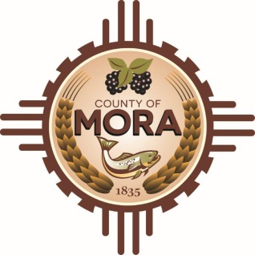***County Commissioners***

***George Trujillo Joseph Garcia***

*Commission Chair County Manager*

***Johnny Trujillo***

*Commission Vice-Chair*

***Veronica Serna***

*Member*

**Invitation For Bid**

Mora County is requesting Bids for Purchase of Semi-Truck 7/1/2024. The following Specifications are what we are interested in: 2020 or newer, 400 HP Cummins Engine, 10 Bew Tires, A Wet Kit with 2 lines, 10-15 speed transmission, less than 170,000 miles, a beacon light (top of cab), and a warranty of 12 months or 50,000 miles whichever occurs first. Interested parties can mail or hand deliver their proposals to: Mora County Manager’s Office, ATTN: Adelita Encinias, Procurement Officer, 1 Courthouse Drive Mora NM, 87732. Bids must be in sealed envelope that is clearly marked: “Sealed Bid 7/4/24 Purchase of Semi-Truck – DO NOT OPEN.” Please have all proposals in by 10:00 AM on 7/8/2024.

The County of Mora reserves the right to reject all bids submitted.