***Mora County Veterans Memorial Committee***

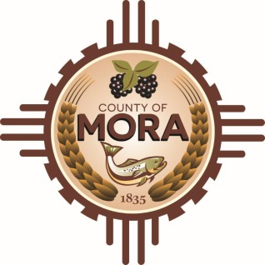

***Joe Gene Pacheco Max Garcia***

**ChairmanTreasurer**

***Harold Nolan Julian Olivas***

**Vice Chair Secretary**

**Veterans Memorial Committee**

**1 Courthouse Drive Mora, NM**

**July 9, 2024**

**1:00 p.m.**

**Agenda**

Zoom Meeting ID: 962 4152 9301

Passcode: 132956

Zoom Link: [**https://zoom.us/j/96241529301?pwd=SDlEdFA5bkxTTlArQWRHeTdOeXl0Zz09**](https://zoom.us/j/96241529301?pwd=SDlEdFA5bkxTTlArQWRHeTdOeXl0Zz09)

Find your local number: Find your local Number: <https://us06web.zoom.us/u/kBS6OqdwW>

1. Call to Order
2. Veterans Salute to the Flag of the United States of America
3. Approval of Agenda
4. Approval of Minutes
5. May 14, 2024
6. June 11, 2024
7. Discussion/Action
8. Budget Report-Max Garcia & Larry Garcia
9. Joseph Garcia, County Manager-Update Report- Contract with Lloyd & Associates Architects
10. Update County Commission Meeting 6-27-24-Larry Garcia
11. Unfinished Business
12. Memorial Construction Project
13. New Business
14. Adjournment

If you are an individual with a disability who is need of a reader, amplifier, qualified sign language interpreter or any other form of auxiliary aid service to attend or participate in the meeting, please contact the Mora County Administration office located on Highway 518, 1 Courthouse Drive, Mora County Courthouse, Mora, New Mexico, as soon as possible at 575-387-5279.

Posted: Bulletin Board, County Website; 7-2-24