Mora County Offices
Including Road and Solid Waste Department WILL BE CLOSED ON Thursday June 20th in observance of Juneteeth
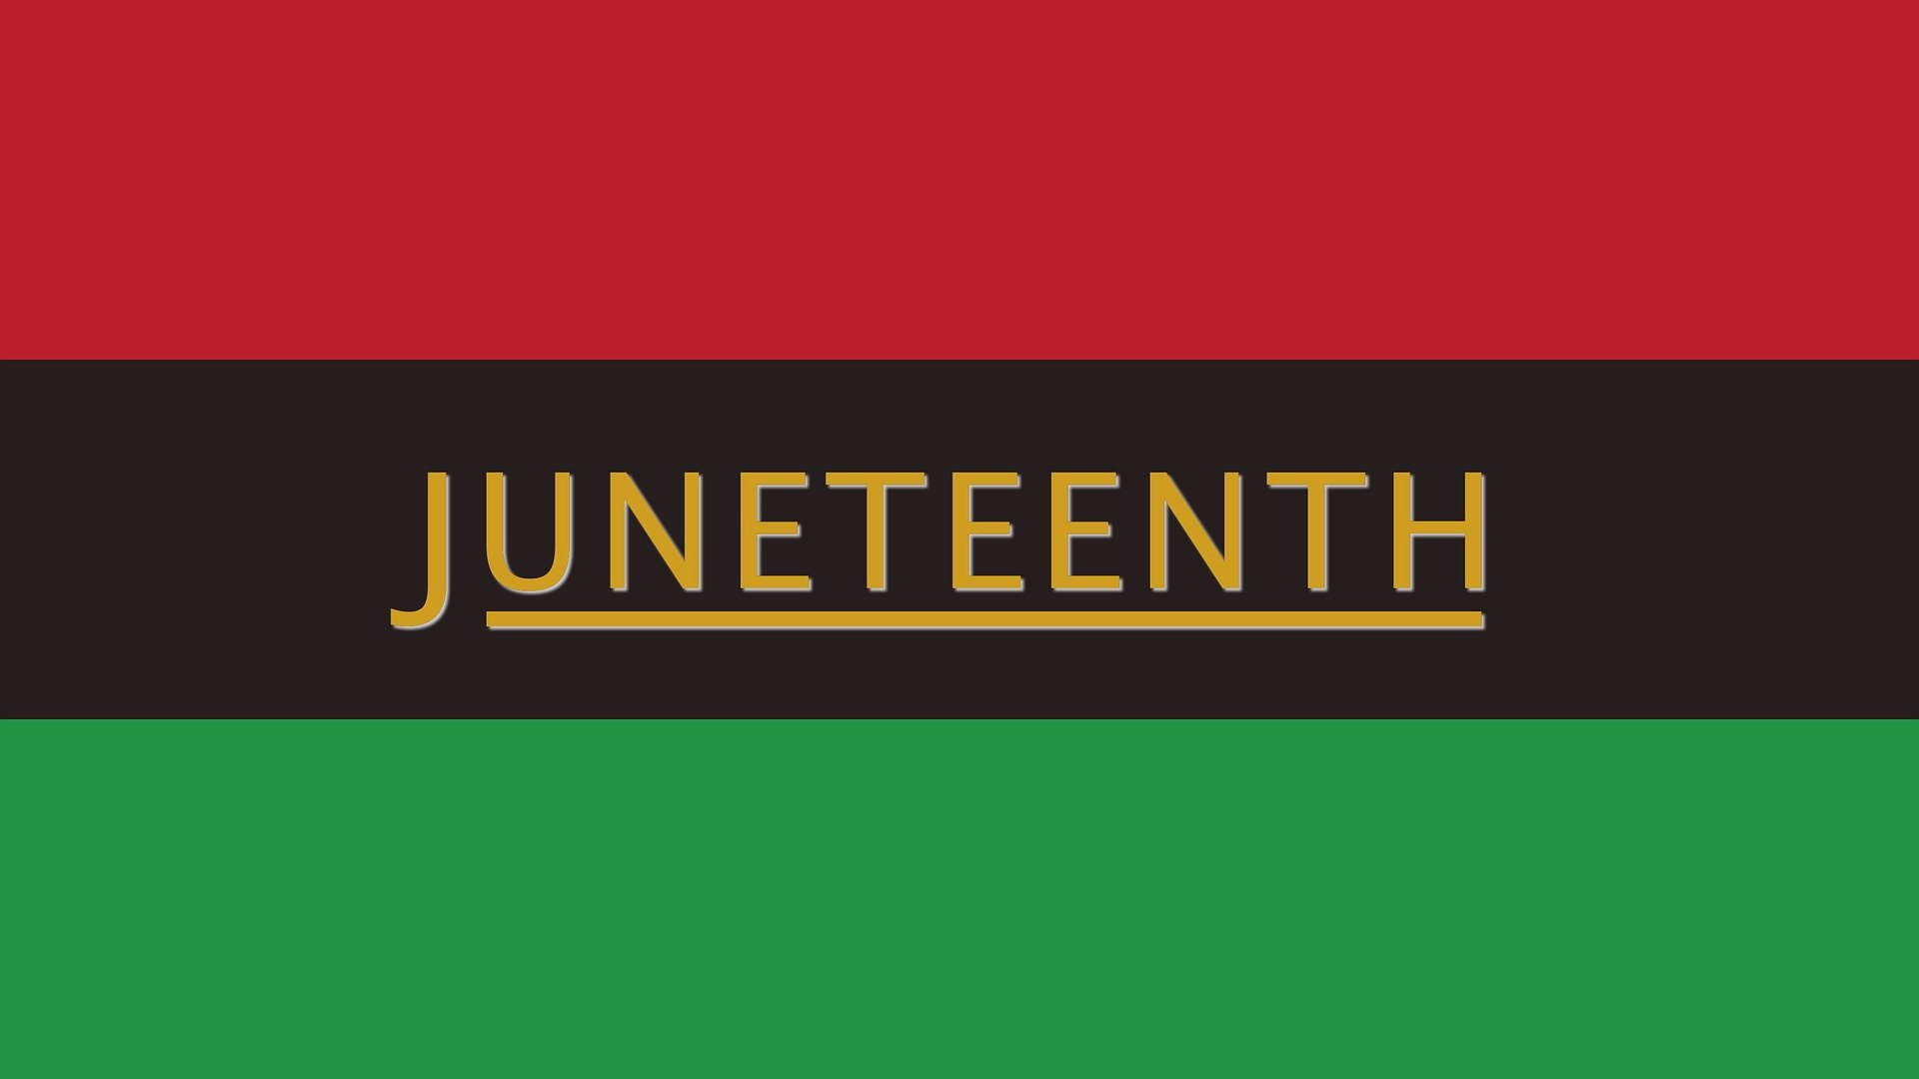

We will resume Regular Business hours on Monday June 24th.
(Solid Waste and Road Department will reopen on Friday and Saturday)
EMS and Sheriff’s Office will follow their Regular Schedule.

