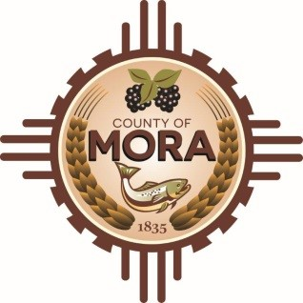

Board of County Commissioners
Public Hearing Budget Work Session
Mora County Commission Chambers
1 Courthouse Drive Mora, NM
Wednesday May 22, 2024
9:00 a.m.

MEETING NOTICE
Join Zoom Meeting
Meeting ID: 964 7469 5503
Passcode: 006848
Zoom Link: https://zoom.us/j/96474695503?pwd=NjZHZDFEWDNKZXBGaktKRWxvR1RQQT09

Find your local number: https://us06web.zoom.us/u/kBS6OqdwW

The Mora County Board of Commission will hold a Public Hearing Budget Work Session on Wednesday May 22, 2024, at 9:00 a.m. at the Mora County Administration Building- Commission Chambers Mora, New Mexico. Agendas may be obtained at the Mora County Manager’s Office on Friday May 17, 2024, at 9:00 a.m. or at https://towncloud.io/go/mora-county-nm/
If you are an individual with a disability who is in need of a reader, amplifier, qualified sign language interpreter, or any other form of auxiliary aid or service to attend or participate in the hearing or meeting, please contact the County Manager’s Office at the Mora County Courthouse at least one week prior to the meeting or as soon as possible. Public documents, including the agenda and minutes, can be provided in various accessible formats. Please contact the Mora County Managers Office at 575-387-5925 if a summary or other accessible format is needed.
If you have difficulties connecting to zoom, call the Manager’s Office at 575-387-5925
PUBLISH:
Posted: Lobby Door, Bulletin Board, and County Website; 5-7-24

