***Mora County Veterans Memorial Committee***

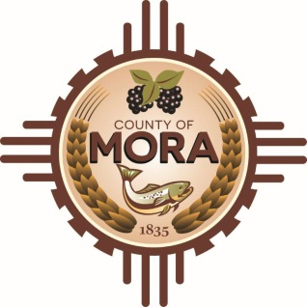

***Joe Gene Pacheco Max Garcia***

**ChairmanTreasurer**

***Harold Nolan Julian Olivas***

**Vice Chair Secretary**

**Veterans Memorial Committee**

**1 Courthouse Drive Mora, NM**

**May 14, 2024**

**1:00 p.m.**

**Agenda**

Zoom Meeting ID: 962 4152 9301

Passcode: 132956

Zoom Link: [**https://zoom.us/j/96241529301?pwd=SDlEdFA5bkxTTlArQWRHeTdOeXl0Zz09**](https://zoom.us/j/96241529301?pwd=SDlEdFA5bkxTTlArQWRHeTdOeXl0Zz09)

Find your local number: Find your local Number: <https://us06web.zoom.us/u/kBS6OqdwW>

1. Call to Order
2. Veterans Salute to the Flag of the United States of America
3. Approval of Agenda
4. Approval of Minutes
5. March 12, 2024
6. April 9, 2024
7. Discussion/Action
8. Nomination of Committee Members
9. Flag Retirement Ceremony Planning June 21, 2024-Committee Member Assignments
10. Update County Commission Meeting April 18, 2024-Larry Garcia
11. Plaque honoring Goldstar honoring Parents and Families
12. Unfinished Business
13. Update-Joseph Garcia, County Manager
14. Update-Max Garcia, Road Designations
15. New Business
16. Adjournment

If you are an individual with a disability who is need of a reader, amplifier, qualified sign language interpreter or any other form of auxiliary aid service to attend or participate in the meeting, please contact the Mora County Administration office located on Highway 518, 1 Courthouse Drive, Mora County Courthouse, Mora, New Mexico, as soon as possible at 575-387-5279.

Posted: Bulletin Board, County Website; 5-9-24