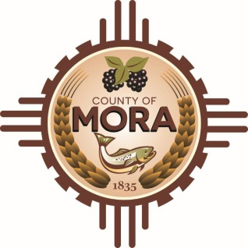

NOTICE OF POSSIBLE QUORUM
Mora County Commission Chambers
1 Courthouse Drive, Mora, NM
Tuesday April 9, 2024, at 1:00 p.m.

The Mora Veterans Memorial Committee will be conducting their regular monthly meeting on Tuesday April 9, 2024, at 1:00 p.m. at the Mora County Commission Chambers.

A possible quorum of the Mora County Commission may attend this meeting; No decisions will be made, or public policy formulated by the Commission members in attendance during the meeting.

Notices of this type are not subject to the Open Meetings Act and instead are issued as a courtesy
to the public.

Publish: Bulletin board and website-4-8-24 at 8:30 a.m.

