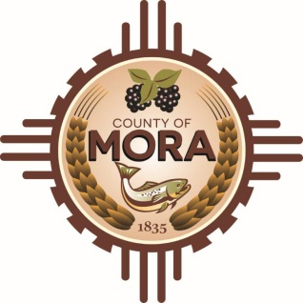
County Commissioners

George A. Trujillo Joseph Garcia
Commission Chair County Manager

Johnny H. Trujillo
Commission Vice-Chair

Veronica M. Serna
Member

Responses to CHET RFP Questions
Please note that there was a delay in providing these responses due to a staffing issue in the Finance Office.
Question 1: Who is the incumbent and what is the annual cost to the government at this present time?
Response 1: There is no incumbent.
Question 2: Is there a mandatory pre-bid meeting?
Response 2: The RFP did not require a mandatory pre-bid meeting.
Question No. 3: Is any form of bonding required?
Response 3: Bonding will be determined during contract negotiations.
Question No. 4: Do you require a local vendor preference?
Response No. 4: The RFP specifies any vendor preferences.
Question No. 5: Will the award be made based on lowest price and based on the vendor demonstrating he/she is the most responsible bidder?
Response No. 5: Award will be based upon evaluation process conducted by the Committee and will be consistent with the New Mexico Procurement Code.

