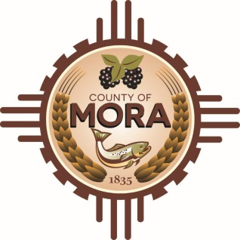
County Commissioners

George Trujillo Joseph Garcia
Commission Chair County Manager

Johnny Trujillo
Commission Vice-Chair

Veronica Serna
Member

April 19, 2024

Mora County will be responding to any questions from the Offerors regarding the CHET Water Tank RFP no later than Tuesday, April 23, 2024, at 2:00 p.m. There has been an unanticipated delay due to staffing within the Procurement Office.

