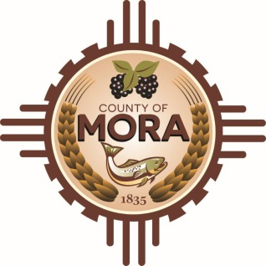
County Commissioners

George Trujillo
Commission Chair

Johnny Trujillo
Commission Vice-Chair

Veronica Serna
Member
NOTICE
Mora County Road Viewer’s Committee
Mora County is looking to fill 3 vacant positions for a Road Viewer’s Committee. The purpose of this Road Viewer’s Committee is to abandon County Road C027 in Wagon Mound.
Residents within a two mile radius of the proposed road have submitted a petition with reasons why the road should be closed. Some of the reasons include: to ensure safety and security of surrounding Haper Cattle Company.
The Road Viewing Committee will be comprised of three members appointed by the County Commission. To be eligible to serve on the Road Viewing Committee, members must meet the following criteria:
- Must be a resident of Mora county
- Two of the three members shall not be residents on the same county road that is the subject of the deliberations of the Road Viewing Committee.
- One member shall be a resident along the road to provide local expertise about the history and use of the road.
- All members of the committee should be unbiased in their deliberations and fairly consider the information provided by the various parties affected by the petition.
- Any and other reasonable criteria approved by the County Commission.
Letters of interest can be submitted to the Mora County Planning and Zoning Department. PO Box 580 Mora N.M. 87732 or to bsena@countyofmora.com. The deadline is April 5, 2024.

