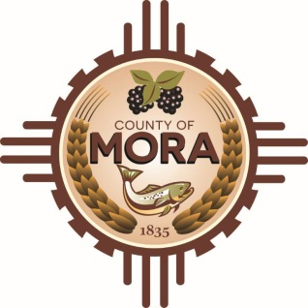

NOTICE OF POSSIBLE QUORUM
Mora County Commission Chambers
1 Courthouse Drive
Mora, NM 87732
Tuesday, March 19, 2024
9:00 a.m.

Members of the County Commission may attend a meeting the purpose of this meeting is to deliver training state procurement requirements, discuss the status of Mora County Senate Bill 6 projects, other active PA projects, unmet needs, and additional resource requests for Mora County relating to the Hermit’s Peak / Calf Canyon fire and subsequent flood events.

No decisions will be made, or public policy formulated by the Commission members in attendance.

Notices of this type are not subject to the Open Meetings Act and instead are issued as a courtesy to the public.

Published: 3-19-24

