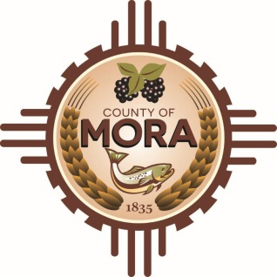

NOTICE OF POSSIBLE QUORUM
Mora County Commission Chambers
1 Courthouse Drive
Mora, NM
Wednesday, March 20, 2024, at 10:30 a.m.

.

The Special Projects Committee will be conducting their regular monthly meeting on Wednesday March 20, 2024, at 10:30 a.m. at the Mora County Commission Chambers.

A possible quorum of the Mora County Commission may attend the meeting. No decisions will be made, or public policy formulated by the Commission members in attendance during the meeting.

Notices of this type are not subject to the Open Meetings Act and instead are issued as a courtesy to the public.

Published: 3-7-24 at 2:00 p.m.

