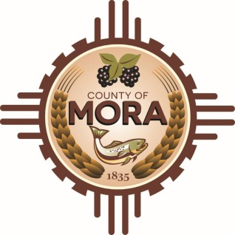

NOTICE OF POSSIBLE QUORUM
Mora County Commission Chambers
1 Courthouse Dr Mora, NM 87732
Wednesday, March 13, 2024, at 8:00 a.m.

The Planning & Zoning Committee will be conducting their regular monthly meeting on Wednesday March 13, 2024, at 8:00 a.m. at the Mora County Commission Chambers.

A possible quorum of the Mora County Commission may attend this meeting. No decisions will be made, or public policy formulated by the Commission members in attendance.

Notices of this type are not subject to the Open Meetings Act and instead are issued as a courtesy to the public.

Published: 3-7-24 @ 2:00 p.m.

