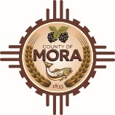
Job Announcement
Mora County
Wildland Coordinator (Part-Time)
Any interested party wishing to present their qualifications for the position must submit a complete application packet, which includes a County Employment application, to the Mora County Manager’s Office. The application and job description can be found at www.countyofmora.com/careers or you can call DesMarie Romero, HR Coordinator at (575) 387-5925. Open until 04/08/2024 at noon.
Mora County is an equal opportunity employer.

