Mora County Offices
Including Road and Solid Waste Department WILL BE CLOSED ON Friday March 29th in observance of Good Friday
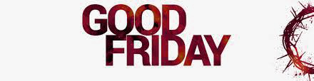We will resume Regular Business hours on Monday April 1st.

EMS and Sheriff’s Office will follow their Regular Schedule.

