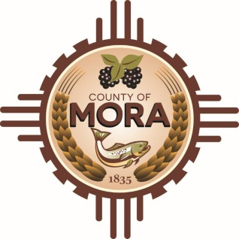
County Commissioners

George Trujillo Joseph Garcia
Commission Chair County Manager

Johnny Trujillo
Commission Vice-Chair

Veronica Serna
Member

MORA COUNTY’S RESPONSE TO QUESTIONS FROM PROSPECTIVE OFFERORS REGARDING DISASTER RECOVERY RFP

Question 1:
On page 9 of the RFP is the EVALUATION CRITERIA. And on pages 13-14 are the B. MANDATORY EVALUATION FACTORS that indicate points are available for responding to items 1.-4.

Is the intent to have the offeror include the MANDATORY EVALUATION FACTORS in the items under the EVALUATION CRITERIA or is the intent to have them addressed separately under a different section.

Answer:
Mora County will defer to each offeror’s decision on how they address each component of the evaluation factors and criteria. The County does not require a specific format so long as the required information is provided by each offeror. As such, offerors are to exercise their discretion in responding to this RFP.

Question 2:
Are respondents required to be architectural/engineering firms or can those services (if needed) be subcontracted to a 3rd party?

Answer:
The RFP does not specifically provide for such a requirement as identified in this question; however, having such capacity in house would be deemed a favorable factor in the evaluation process. In the event such capacity does not exist in house with the offeror, the RFP Response must provide detailed information regarding proposed subcontractors as outlined in the RFP.

Question 3:
Does the County of Mora have a process they are required to follow by state regulations for procurement?

Answer:
Mora County follows the New Mexico Procurement Code.

Question 4:
Do the required attachments (letter of transmittal, COI, collusion, debarment, W9, etc.) count against the 30-page limit?

Answer:
The required attachments (e.g., letter of transmittal, COI, collusion, debarment, W-9, etc.) will not count against the thirty-page limit.

Question 5:
Do resumes count against the 30-page limit?

Answer:
Resumes will not count against the thirty-page limit.

Question 6:
There does not appear to have any criteria or incentive to attract small, disadvantaged, minority, woman-owned or other types of firms. Will the County of Mora consider adding this to the criteria? Or will such a proposer receive consideration for being one of these business types if they meet the criteria?

Answer:
Mora County will adhere to the criteria listed in the RFP and New Mexico’s State Procurement Code, if applicable.

Please note that offerors are welcome to identify such factors, including but not limited to those identified in this question, which offerors believe to be relevant.

Question 7:
What qualifies a person or firm as a "major" subcontractor?

Answer:
“Major” subcontractor is not defined in the RFP and is left to the discretion of the offeror for purposes of responding to the RFP. Upon contract execution, the County’s Finance Department will work with the contractor to ensure all subcontractors (major or otherwise) are properly identified based upon the nature of work to be performed.

