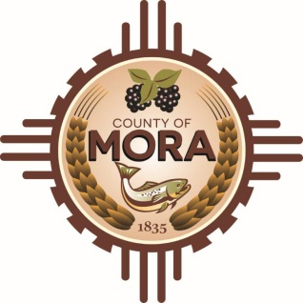

NOTICE OF POSSIBLE QUORUM
Mora County Commission Chambers
1 Courthouse Drive
Wednesday, February 28, 2024

Singleton Schreiber, the County's outside counsel in the HPCC claim process, will be onsite at the County conducting interviews throughout the day on February 28, 2024. A quorum of the county commission might visit with counsel during the interview process for informational purposes.

No decisions will be made during this process or public policy formulated by the Commission members in attendance.

Notices of this type are not subject to the Open Meetings Act and instead are issued as a courtesy to the public.

Published: 2-22-24 at 11:30 a.m.

