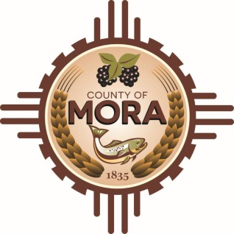

NOTICE OF POSSIBLE QUORUM
Mora County Complex and
David Cargo Library
NM-518 Mora, NM 87732
Wednesday, February 28, 2024

Members of the County Commission may attend a meeting at the David Cargo Library with FEMA officials at 11:00 am for a “meet and greet”.

Members of the County Commission may visit with legal counsel addressing the HPCC Claim with the County’s legal team, Singleton Schreiber, at meetings throughout the day.

No decisions will be made, or public policy formulated by the Commission members in attendance.

Notices of this type are not subject to the Open Meetings Act and instead are issued as a courtesy to the public.

Published: 2-28-24 at 10:00

