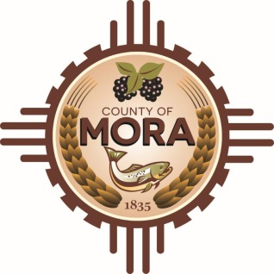

NOTICE OF POSSIBLE QUORUM
David Cargo Library
NM-518 Mora, NM 87732
Wednesday, February 28, 2024, at 2:00 p.m.

Members of the County Commission may attend a meeting at the David Cargo Library regarding Monte Aplanado Road.

No decisions will be made, or public policy formulated by the Commission members in attendance.

Notices of this type are not subject to the Open Meetings Act and instead are issued as a courtesy to the public.

Published: 2-26-24 at 11:25 a.m.

