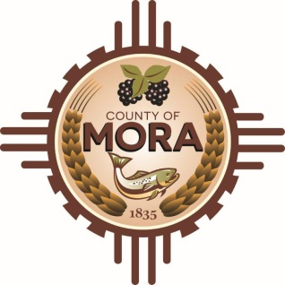

NOTICE OF POSSIBLE QUORUM
Santa Fe, NM 87501
Friday, February 23, 2024, at 9:00 a.m.

Members of the County Commission may attend a meeting at the office of Lloyd and Associates Architects to discuss the plans for construction of the County Complex and Courthouse

No decisions will be made, or public policy formulated by the Commission members in attendance.

Notices of this type are not subject to the Open Meetings Act and instead are issued as a courtesy to the public.

Published: 2-23-24

