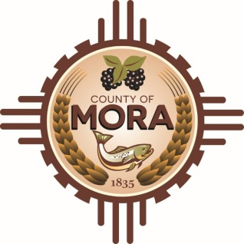

NOTICE OF POSSIBLE QUORUM
Mora County Commission Chambers
1 Courthouse Drive
Mora, NM
Wednesday, January 24, 2024, at 10:00 a.m.

A potential quorum of the County Commission may attend a meeting with Special Projects Committee to discuss updates on Construction of Mora County Complex.

No decisions will be made, or public policy formulated, by the Commission members in attendance during the meeting.

Notices of this type are not subject to the Open Meetings Act and instead are issued as a courtesy to the public.

Published: 1/22/24 at 9:30

